Selenium WebDriver Architectue Simplified:

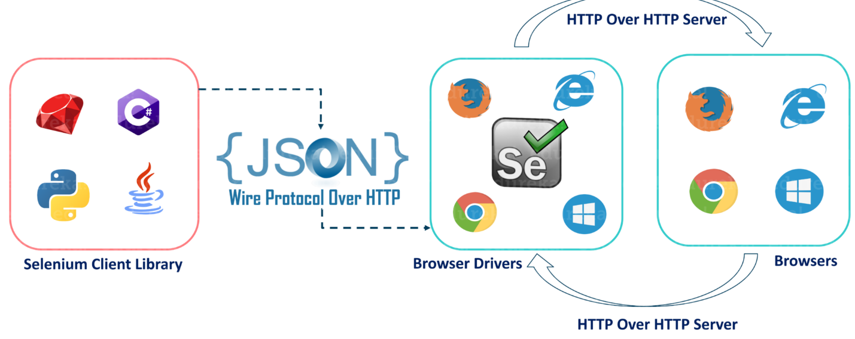

* After you trigger the Test, complete Selenium code (Client) which we have written will be converted to Json format
* Generated Json is sent to Browser Driver (Server) through http Protocol

Note: Each browser contains a separate browser driver

* . Browser drivers communicate with its respective browser and executes the commands by interpreting Json which It received on the browser.
* Browser Driver receives responses back from the browser and it sends Json response back to Client.

Basically, you need an editor to write your code. we will download an editor called Eclipse, where we will start writing about

selenium code.

So write to us selenium code in any of your favorite language.

Completed writing your selenium testcase and run the test all the selenium code for that particular test case, whatever you are written, will be converted JSON

Now, what is browser driver?

every browser have its own browser driver.

Now, for example, if you want to automate in Chrome browser for Chrome, you will have a server called

Browser Driver, which we say as a Chrome driver

So browser driver will read your code and if something is written as a click, so then it will

initiate click action on its driver.

OK, so these are interlinked, your browser and browser driver together

For example, if you ask to click, it will click and it will give the response back.

So that corresponds again sent back to browser driver.

So this browser driver will again grab that response in decent format and send it back to our client

code.

That means we will see the output in our editor after we receive the response back as a decent format

to our test.

But do remember that your code is not directly interacting with browser.

In the middle there is a server called a browser driver.

You are sending your code to browser driver first and browser driver is responsible to automate on the

browser.

Your code is not directly doing that.

You are taking the help of this browser driver.

If you are working with Chrome browser, you will go and download Chrome Driver first.

Assuming that you are running in Chrome, you will first go and download this browser driver available

on the Internet.

You will download that and you will give the part where exactly it got downloaded in your selenium script.

if you don't give the part in your test that this is where browser driver is present in my mission,

then just this and do not know where to go, your script will simply fail.